KHOA CÔNG NGHỆ THÔNG TIN
TRƯỜNG ĐẠI HỌC GIAO THÔNG VẬN TẢI
TP.HỒ CHÍ MINH
____________________________


BÁO CÁO
CÔNG NGHỆ PHẦN MỀM
Giảng Viên: Trần Thị Mỹ Tiên

TP.HCM – NĂM 2026

Phone Book Management System
Specification

TABLE OF CONTENTS
I. Functional Requirements
II. Non-Functional Requirements
III. Data Flow Diagram
1. Level 0
2. Level 1
IV. Use Case Diagram
V. Class Diagram
VI. Data Model

- Functional Requirements
- Contact Management
- Add a new contact to the phone book, including full name, phone number, email address, physical address, profile picture, and notes.
- The system validates input data, requiring a full name and phone number, and checks the validity of the phone number.
- Update the information of an existing contact.
- Delete one or multiple contacts from the phone book. The system displays a confirmation dialog before permanently deleting the selected contacts.
- Search for contacts by name, phone number, or email address.
- The system supports partial matching when users enter search keywords.
- Sort contacts alphabetically in ascending (A–Z) or descending (Z–A) order.
- Allow users to mark contacts as favorites or remove them from the favorites list.
- Favorite List Management
- The system displays a separate list of contacts marked as favorites.
- Users can add contacts to or remove contacts from the favorites list without deleting their information from the main contact list.
- The system allows users to sort the favorites list by priority level or frequency of communication.
- Phone and Contact Management
- Users can create, edit, and delete contact groups (e.g., Family, Work, and Friends).
- Users can assign contacts to groups or remove contacts from groups.
- The system displays detailed contact profiles, including secondary phone numbers, work addresses, birthdays, and personal notes.
- The system detects contacts with duplicate names or phone numbers and suggests merging or deleting duplicate records.
- User Account Management
- The Admin can view a list of all user accounts registered in the system.
- The Admin can search for user accounts by username or email address.
- The Admin can view detailed information about a user account.
- The Admin can lock a user account to prevent the user from logging into the system.
- The Admin can unlock a locked account, allowing the user to access the system again.
- The Admin can monitor account statuses, including active and locked.

- Account Management
- Users can log in to and log out of the system using their username or email address and password.
- Users can change their passwords by verifying their current passwords and setting new ones.
- Users can register for an account to use the system.
- Users can view and update their personal information, including full name, email address, profile picture, and personal phone number.
II. Non-Functional Requirements
1. Performance
- The system must display the contact list within 2 seconds under normal operating conditions.
- The system must return search results within 2 seconds, even when searching through a database containing 10,000+ contacts.
- The system must support at least 100 concurrent users without significant performance degradation.
- Adding, updating, or deleting a contact must be processed within 2 seconds.
2. Security
- The system requires user authentication (login) before allowing access to personal contact information.
- Passwords must be encrypted or securely hashed before being stored in the database.
- The system must implement role-based access control to distinguish between Admin and regular Users.
- Only the Admin is allowed to view, lock, and unlock user accounts.
- Users can only access and manage their own contact information.
- The system must protect personal information from unauthorized access, modification, or disclosure.

3. Availability and Reliability
- The system must be available at least 99% of the time during normal operation.
- The system must handle invalid inputs (e.g., incorrect phone numbers, invalid email addresses, or missing required fields) without crashing.
- The system must automatically save changes to prevent data loss.
- The system must maintain stable operation during continuous use without unexpected errors.
- The system must provide appropriate error messages when operations fail.
4. Usability
- The user interface must be simple, intuitive, and easy to navigate.
- The system must provide clear instructions, labels, and error messages to guide users through each function.
- Users must be able to perform common operations, such as adding, searching, editing, and deleting contacts, with minimal steps.
- The system must display confirmation messages after successfully completing important operations.
- The system must provide a confirmation dialog before permanently deleting contacts or performing other critical actions.
5. Scalability
- The system must support an increasing number of users and contacts without significant performance degradation.
- The database structure must allow the storage and management of at least 100,000 contact records.
- The system architecture must allow new features, such as contact synchronization, contact import/export, and additional contact groups, to be added without major changes to existing components.
6. Maintainability
- The source code must be clearly structured, well-organized, and easy to understand, maintain, and upgrade.
- The system must use modular components to simplify debugging and future development.
- Technical documentation must be complete and accurate.
- The system must allow developers to fix bugs and update individual components without significantly affecting other functions.
7. Data Integrity and Backup
- The system must ensure that contact information remains accurate and consistent throughout all operations.
- The system must prevent duplicate contact records when adding or updating contacts.
- The system must automatically back up important data to prevent permanent data loss.
- The system must support data recovery in case of system failures or unexpected errors.
- Deleting a contact from the favorites list must not delete the contact from the main contact list.
III. Data Flow Diagram
- Level 0
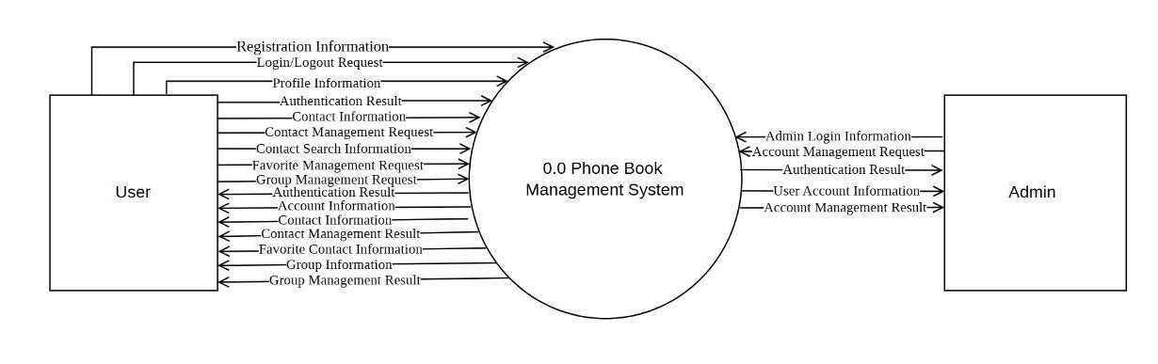
- Level 1
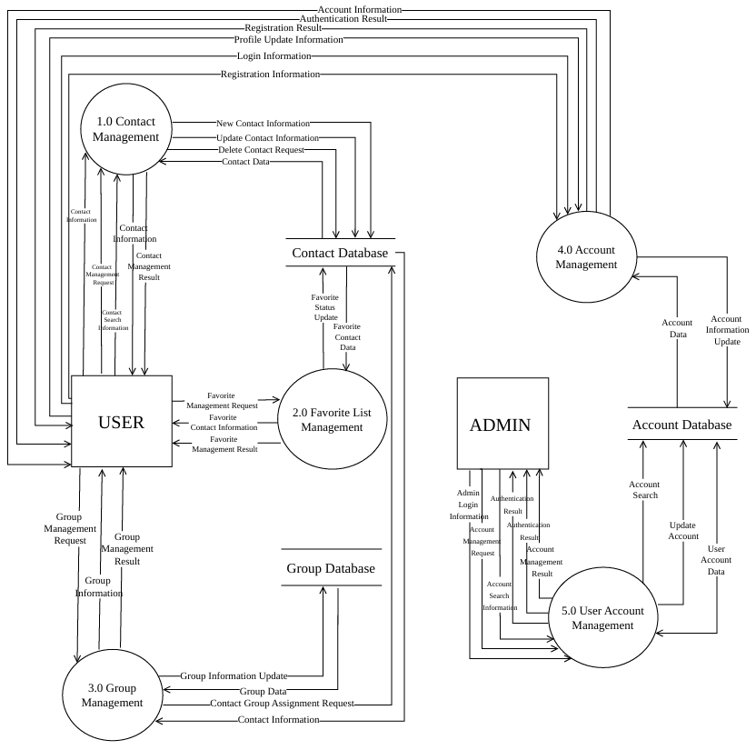
  - Contact Management
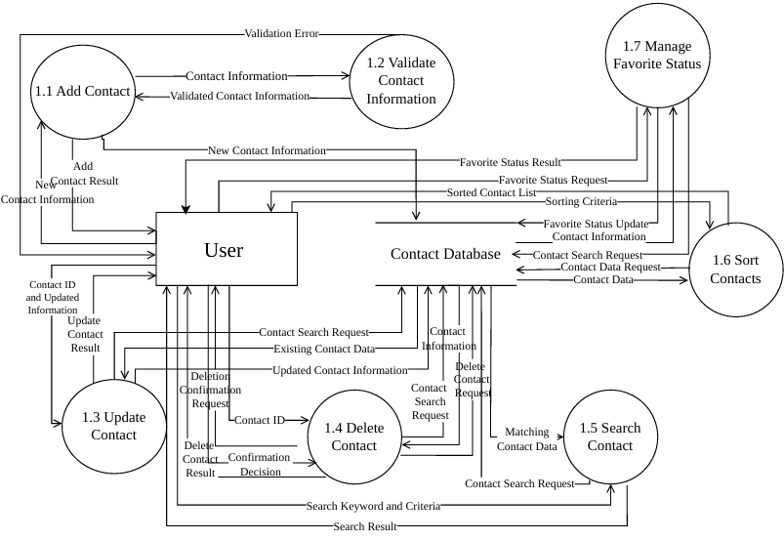

  - Favorite List Management
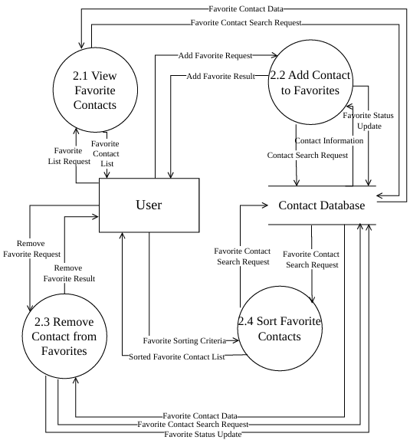
  - Group Management
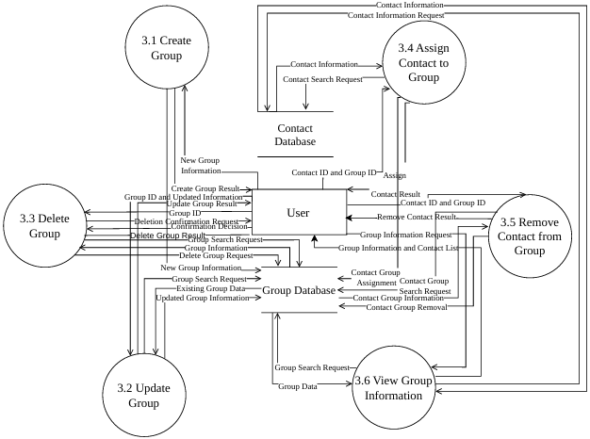
  - Account Management
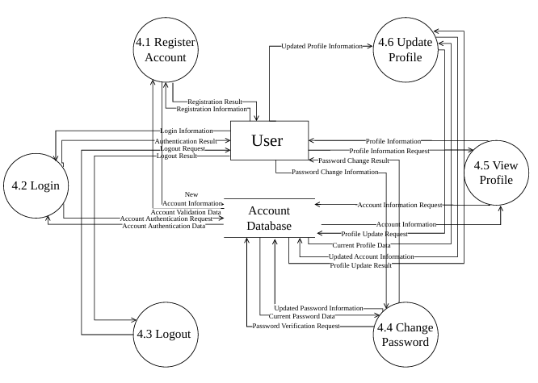

  - User Account Management
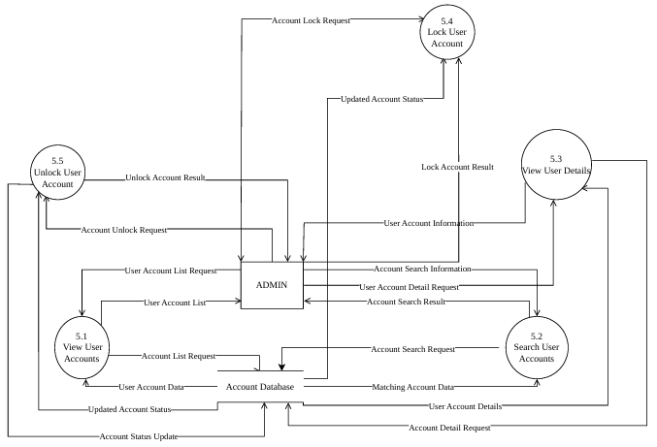

IV. Use Case Diagram
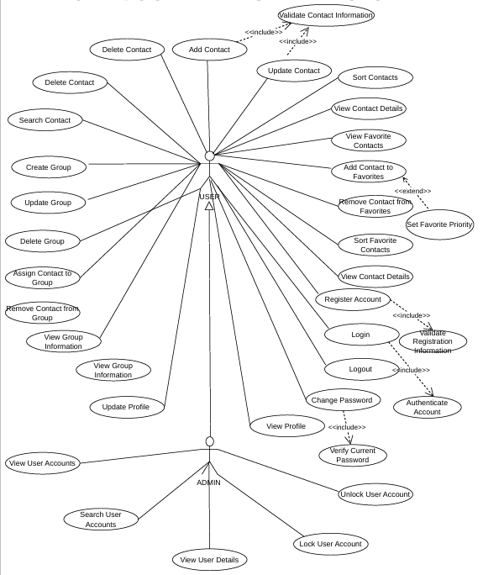

3. Actors

3.1. USER
USER is the primary actor and represents a person using the phone book application. The user can manage personal contacts, organize them into groups, mark important contacts as favorites, and manage their own account information.
- Contact management: add, delete, update, search, sort, and view contact details.
- Favorite management: add contacts to favorites, remove them from favorites, and view favorite contacts.
- Group management: create, update, and delete groups; assign or remove contacts; and view group information.
- Personal account management: register, log in, log out, view and update the profile, and change the password.

3.2. ADMIN
ADMIN is the administrator actor responsible for managing user accounts. The diagram uses a Generalization relationship from ADMIN to USER: the hollow triangle points to USER. This indicates that ADMIN inherits the interactions available to USER and has additional administrative capabilities.
- View the list of user accounts.
- Search for user accounts.
- View the details of a selected user account.
- Lock a user account.
- Unlock a user account.

4. Use Case Descriptions

4.1. Contact Management
This is the core functional group. A contact may contain a name, phone number, email address, postal address, notes, and other fields depending on the implementation scope.

4.1.1. Add Contact
Attribute | Description
Actor | USER
Purpose | Create a new contact record.
Preconditions | The user has opened the application and has access to the contact book.
Main flow | 1. Select Add Contact.  2. Enter contact details.  3. The system invokes Validate Contact Information.  4. The system checks required fields, formats, and applicable constraints.  5. If valid, the system saves the contact and displays confirmation.
Alternative / exception flows | Missing required fields, invalid phone/email formats, or a duplicate according to system rules cause an error message and a request to correct the data.
Postconditions | The new contact is stored and can appear in lists, search results, and relevant groups.

4.1.2. Delete Contact
Attribute | Description
Actor | USER
Purpose | Remove an existing contact from the contact book.
Preconditions | The selected contact exists and the user is authorized to manage it.
Main flow | 1. Select a contact.  2. Choose Delete.  3. The system requests confirmation.  4. The user confirms.  5. The system deletes the contact and reports the result.
Alternative / exception flows | If the user cancels, the contact remains unchanged. If the contact no longer exists, the system displays an appropriate message.
Postconditions | The contact is removed. Related favorite/group references must be handled consistently.

4.1.3. Update Contact
Attribute | Description
Actor | USER
Purpose | Modify the information of an existing contact.
Preconditions | The contact exists in the user's contact book.
Main flow | 1. Select the contact.  2. Open Update Contact.  3. Edit the required fields.  4. The system invokes Validate Contact Information.  5. If valid, the system saves the changes and confirms success.
Alternative / exception flows | Invalid data is rejected; the system identifies the fields that need correction and does not save invalid values.
Postconditions | The contact information is updated.

4.1.4. Search Contact
Attribute | Description
Actor | USER
Purpose | Find contacts using a keyword or search criteria.
Preconditions | The contact book is accessible.
Main flow | 1. Enter a keyword or search criteria.  2. The system searches supported fields, such as name or phone number.  3. Matching contacts are displayed.
Alternative / exception flows | If no match is found, the system displays a no-results message. Empty input may be rejected or handled according to the search rules.
Postconditions | Matching contacts or a no-results message are displayed.

4.1.5. Sort Contacts
Attribute | Description
Actor | USER
Purpose | Arrange the contact list according to a selected criterion.
Preconditions | The contact book contains contact records.
Main flow | 1. Select a sorting criterion, such as name or alphabetical order.  2. Select ascending/descending order if supported.  3. The system sorts and displays the contacts.
Alternative / exception flows | If the list is empty, the system displays an empty state. An unsupported criterion is rejected.
Postconditions | The contact list is displayed in the selected order.

4.1.6. View Contact Details
Attribute | Description
Actor | USER
Purpose | Display the full information of a selected contact.
Preconditions | The selected contact exists.
Main flow | 1. Select a contact from a list or search result.  2. The system retrieves its information.  3. The system displays the available details.
Alternative / exception flows | If the contact has been deleted or cannot be retrieved, the system displays an error and returns to the list.
Postconditions | The selected contact's details are displayed.

4.2. Favorite Contact Management
This group allows users to mark important contacts for quick access. Favorite status should normally be stored as an attribute or relationship associated with a contact, rather than creating a duplicate contact record.

4.2.1. Add Contact to Favorites
Attribute | Description
Actor | USER
Purpose | Mark a contact as a favorite/high-priority contact.
Preconditions | The contact exists and is not already marked as a favorite.
Main flow | 1. Select a contact.  2. Choose Add to Favorites.  3. The system updates its favorite status.  4. If needed, the user can set a priority through Set Favorite Priority.
Alternative / exception flows | If the contact is already a favorite, the system keeps the current state or displays an informational message.
Postconditions | The contact is marked as a favorite.

4.2.2. Remove Contact from Favorites
Attribute | Description
Actor | USER
Purpose | Remove the favorite status from a contact.
Preconditions | The contact is currently marked as a favorite.
Main flow | 1. Open the favorites list.  2. Select a contact.  3. Choose Remove from Favorites.  4. The system updates the status.
Alternative / exception flows | If the contact is not in favorites, the system displays an informational message and leaves the data unchanged.
Postconditions | The contact is no longer displayed in the favorites list.

4.2.3. View Favorite Contacts
Attribute | Description
Actor | USER
Purpose | Display all contacts marked as favorites.
Preconditions | The user can access the contact book.
Main flow | 1. Select Favorite Contacts.  2. The system filters contacts with favorite status.  3. The results are displayed.
Alternative / exception flows | If no favorite contacts exist, the system displays an empty list or an explanatory message.
Postconditions | The favorite contact list is displayed.

4.2.4. Set Favorite Priority
Attribute | Description
Actor | USER
Purpose | Assign or change the priority level of a favorite contact.
Preconditions | The contact has been or is being added to favorites.
Main flow | 1. Select a favorite contact.  2. Choose a priority level.  3. The system validates the value.  4. The system saves the priority.
Alternative / exception flows | A value outside the allowed priority set is rejected and the user is asked to select a valid value.
Postconditions | The contact's priority is updated.

4.3. Contact Group Management
Groups help users classify contacts. Based on the project scope, contacts may be organized alphabetically or by highlighted/favorite status. A manually created group should be distinguished from an automatic alphabetical or favorite filter.

4.3.1. Create Group
Attribute | Description
Actor | USER
Purpose | Create a new contact group.
Preconditions | The user is authorized to manage the contact book.
Main flow | 1. Select Create Group.  2. Enter the group name and details.  3. The system validates the group name.  4. The system saves the group.
Alternative / exception flows | An empty or duplicate group name is rejected according to the system rules.
Postconditions | The new group is created and can receive contacts.

4.3.2. Update Group
Attribute | Description
Actor | USER
Purpose | Change the name or details of an existing group.
Preconditions | The target group exists.
Main flow | 1. Select the group.  2. Choose Update.  3. Edit the details.  4. The system validates and saves the changes.
Alternative / exception flows | If the group does not exist or the new name is invalid, the system reports the error and does not save.
Postconditions | The group information is updated.

4.3.3. Delete Group
Attribute | Description
Actor | USER
Purpose | Delete a group from the group list.
Preconditions | The target group exists.
Main flow | 1. Select the group.  2. Choose Delete.  3. Confirm the operation.  4. The system deletes the group.
Alternative / exception flows | If the user cancels, the group remains. The system must define whether deleting a group removes only membership links or also deletes contacts.
Postconditions | The group is deleted; contact records should be preserved according to the defined policy.

4.3.4. Assign Contact to Group
Attribute | Description
Actor | USER
Purpose | Add a contact to a selected group.
Preconditions | Both the contact and the group exist.
Main flow | 1. Select a group.  2. Select a contact.  3. The system checks for an existing membership link.  4. The system stores the relationship.
Alternative / exception flows | If the contact is already assigned, the system keeps the existing relationship or informs the user. Missing records cause rejection.
Postconditions | The contact appears in the selected group.

4.3.5. Remove Contact from Group
Attribute | Description
Actor | USER
Purpose | Remove the relationship between a contact and a group.
Preconditions | The contact is currently assigned to the selected group.
Main flow | 1. Open the group.  2. Select the contact.  3. Choose Remove from Group.  4. The system deletes the membership link.
Alternative / exception flows | If the contact is not a member, the system displays an informational message and makes no change.
Postconditions | The contact is removed from that group but remains in the contact book.

4.3.6. View Group Information
Attribute | Description
Actor | USER
Purpose | View a group's details and member contacts.
Preconditions | The group exists.
Main flow | 1. Select a group.  2. The system retrieves the group details and its members.  3. The information is displayed.
Alternative / exception flows | If the group has no members, the group is displayed with an empty-members state.
Postconditions | The group information is displayed.

4.4. Account and Personal Profile Management

4.4.1. Register Account
Attribute | Description
Actor | Prospective user
Purpose | Create a new account for system access.
Preconditions | The prospective user does not already have a valid account.
Main flow | 1. Open the registration screen.  2. Enter registration information.  3. The system invokes Validate Registration Information.  4. If valid, the system creates the account and confirms the result.
Alternative / exception flows | Missing data, duplicate email/username, or a password that violates policy causes validation errors.
Postconditions | A new account is created.

4.4.2. Login
Attribute | Description
Actor | USER
Purpose | Authenticate a user and grant access.
Preconditions | The account has been registered and is not locked.
Main flow | 1. Enter login credentials.  2. The system invokes Authenticate Account.  3. If credentials are valid, a session is created and authorized functions become available.
Alternative / exception flows | Invalid credentials, a locked account, or a nonexistent account results in denied access and an appropriate message.
Postconditions | The user is authenticated or access is denied.

4.4.3. Logout
Attribute | Description
Actor | USER
Purpose | End the current user session.
Preconditions | The user is logged in.
Main flow | 1. Select Logout.  2. The system terminates the session and returns to the login screen.
Alternative / exception flows | If the session has already expired, the system returns the user to the unauthenticated state.
Postconditions | The current session is terminated.

4.4.4. View Profile
Attribute | Description
Actor | USER
Purpose | View personal account information.
Preconditions | The user is logged in.
Main flow | 1. Select View Profile.  2. The system retrieves the profile.  3. The system displays permitted information.
Alternative / exception flows | If the session expires or the profile cannot be retrieved, the system requests re-authentication or displays an error.
Postconditions | The profile information is displayed.

4.4.5. Update Profile
Attribute | Description
Actor | USER
Purpose | Modify personal profile information.
Preconditions | The user is logged in.
Main flow | 1. Open the profile.  2. Select Update.  3. Edit the information.  4. The system validates the data. 5) Save the changes.
Alternative / exception flows | Invalid data is rejected and is not saved.
Postconditions | The personal profile is updated.

4.4.6. Change Password
Attribute | Description
Actor | USER
Purpose | Change the account password.
Preconditions | The user is logged in.
Main flow | 1. Enter the current and new passwords.  2. The system invokes Verify Current Password.  3. If the current password is correct, the system validates the new password.  4. The new password is securely stored and confirmation is displayed.
Alternative / exception flows | An incorrect current password or a new password that violates policy causes the operation to be rejected.
Postconditions | The account password is changed.

4.5. User Account Administration
These administrative use cases are assigned to ADMIN. Because of the actor generalization shown in the diagram, ADMIN also inherits USER interactions, subject to the system's authorization policy.

4.5.1. View User Accounts
Attribute | Description
Actor | ADMIN
Purpose | View the list of user accounts managed by the system.
Preconditions | ADMIN is logged in and has administrative permission.
Main flow | 1. Open account management.  2. The system retrieves the account list.  3. Relevant summary information is displayed.
Alternative / exception flows | If there are no accounts or the data cannot be loaded, the system displays the appropriate state.
Postconditions | The user account list is displayed.

4.5.2. Search User Accounts
Attribute | Description
Actor | ADMIN
Purpose | Find accounts by name, email, username, or supported criteria.
Preconditions | ADMIN has administrative permission.
Main flow | 1. Enter a search keyword.  2. The system searches user accounts.  3. Matching results are displayed.
Alternative / exception flows | If no match is found, the system reports no results. Invalid search input is rejected.
Postconditions | Matching user accounts are displayed.

4.5.3. View User Details
Attribute | Description
Actor | ADMIN
Purpose | View detailed information about a selected account.
Preconditions | The account exists and ADMIN has permission to view it.
Main flow | 1. Select an account.  2. The system retrieves its data.  3. Permitted details are displayed.
Alternative / exception flows | If the account does not exist or access is unauthorized, the system denies the request and reports the issue.
Postconditions | The account details are displayed.

4.5.4. Lock User Account
Attribute | Description
Actor | ADMIN
Purpose | Prevent a selected account from logging in or using restricted functions.
Preconditions | The account exists, can be locked, and ADMIN has the required permission.
Main flow | 1. Select the account.  2. Choose Lock.  3. Confirm the action.  4. The system changes the account status to locked.
Alternative / exception flows | If the account is already locked or the action is invalid, the system reports it. A rule should prevent locking the last administrator account.
Postconditions | The account status becomes locked.

4.5.5. Unlock User Account
Attribute | Description
Actor | ADMIN
Purpose | Restore login access to a locked account.
Preconditions | The account is currently locked.
Main flow | 1. Find and select the account.  2. Choose Unlock.  3. Confirm the action.  4. The system changes the status to active.
Alternative / exception flows | If the account is not locked or does not exist, the system displays an appropriate message.
Postconditions | The account is unlocked.

5. UML Relationships in the Diagram
UML relationship | Meaning | Representation in this diagram
Association | A solid line connecting an actor to a use case; it indicates participation in or initiation of the function. | USER is associated with contact, favorite, group, and personal-account functions. ADMIN is associated with account-administration functions.
<<include>> | The base use case always invokes the included use case as a required or reusable sub-function. The dashed arrow points to the included use case. | Add Contact and Update Contact include Validate Contact Information; Register Account includes Validate Registration Information; Login includes Authenticate Account; Change Password includes Verify Current Password.
<<extend>> | An optional or conditional behavior extends a base use case. The dashed arrow points to the base use case. | Set Favorite Priority is represented as an extension of Add Contact to Favorites when the user chooses to assign a priority.
Generalization | A specialized actor inherits the interactions of a general actor. The hollow triangle points to the general actor. | ADMIN inherits USER interactions and adds account-administration functions.

Validate Contact Information, Validate Registration Information, Authenticate Account, and Verify Current Password are supporting use cases, not independent actors.

6. Overall Business Flows

6.1. Contact Management Flow
- The user logs in to the system.
- The user selects an operation: add, view, update, delete, search, or sort contacts.
- For adding or updating, the system validates the contact information.
- The system performs the requested data operation and returns a result.
- The contact list is refreshed so the user can continue.

6.2. Favorite Management Flow
- The user selects a contact from the contact book.
- The user adds the contact to favorites or removes it from favorites.
- When adding and when needed, the user sets a priority level.
- The system updates the status and displays the favorite list when requested.

6.3. Group Management Flow
- The user creates a group or selects an existing group.
- The user updates/deletes the group or assigns/removes contacts.
- The system validates the group and contact records, then updates membership relationships.
- The user views the group details and its member list.

6.4. Account Administration Flow
- ADMIN logs in using an account with administrative privileges.
- ADMIN views the account list or searches for an account.
- ADMIN opens the account details for review.
- ADMIN locks or unlocks the selected account.
- The system updates the account status and records the result.

7. Business Rules and Data Considerations
- Each contact should have a unique identifier. Phone numbers should be validated and normalized before storage.
- The required contact fields must be defined, such as a name or at least one contact method.
- Deleting a contact must consistently handle favorite status, group memberships, and related history; orphaned references must not remain.
- The specification must clarify whether a contact can belong to multiple groups or only one group.
- Favorites should normally be represented as a contact status or user-contact relationship. Priority is meaningful only for a favorite contact.
- Registration and login must enforce account uniqueness, validate credentials, and protect passwords using a secure password-hashing mechanism.
- ADMIN actions must be restricted to authorized administrators. Lock/unlock operations should be controlled and auditable.
- Call history and data backup were mentioned as extended project requirements, but they are not represented as explicit use cases in the supplied diagram. If they remain in scope, add corresponding use cases and connect them to USER.

8. Diagram Review and Recommendations
- The diagram covers several important areas: contacts, favorites, groups, personal accounts, and user administration.
- Some use case labels appear more than once, including Delete Contact, View Contact Details, and View Group Information. Keep one use case per behavior unless the duplicates represent genuinely different contexts or goals.
- Use consistent verb–object naming, such as Add Contact, Update Contact, and Search Contact.
- Check include/extend arrow directions: include points to the included use case; extend points to the base use case.
- Set Favorite Priority is best modeled as optional behavior extending Add Contact to Favorites; its extension condition should be documented.
- A system boundary rectangle should enclose all use cases, with the system name placed on the boundary.
- Add missing use cases if required by the project scope: View Call History and Backup/Export Contacts (CSV, DOC, or supported formats). Data restoration may also be needed if supported.
- Clarify whether ADMIN truly inherits all USER functions. If administrators cannot use personal contact-book functions, avoid actor generalization and connect ADMIN only to the functions it is authorized to perform.

V. Class Diagram
The class structure follows OOP by separating contact data, contact-list operations, call-history records, export functions and the console menu. ContactBook handles CRUD/search/sort/group/favorite behavior. CallHistory manages call records. ExportManager writes external files, while PhoneBookApp coordinates user interaction.
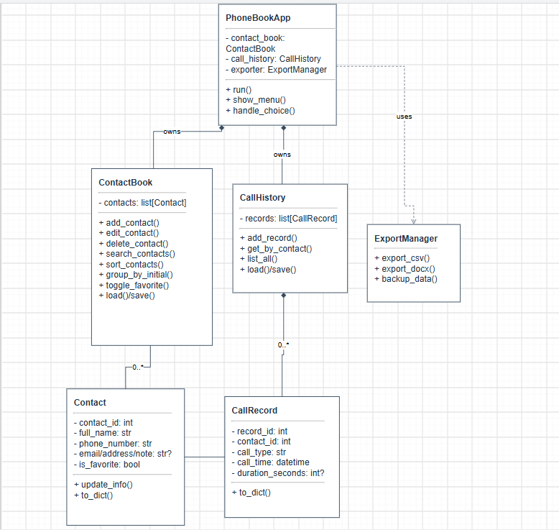

VI. Data Model
